UNIVERSITY OF ENGINEERING AND TECHNOLOGY PESHAWAR

DEPARTMENT OF COMPUTER SYSTEM ENGINEERING

*Digital Image Processing*

*Assignment no: 2*



Spring 2024

Submitted by:

Maaz Habib

Registration No.:

20pwcse1952

Class Section:

C

Submitted to:

Dr. Abeer Irfan

27 MAY 2024

Implementation of histogram equalization and histogram matching (Python/MATLAB)

Histogram Equalization:

Installing library:

Importing libraries:

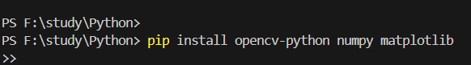

Loading image:

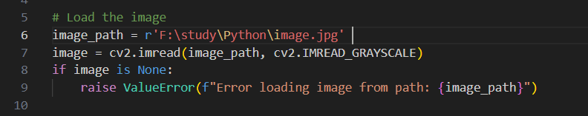

Histogram Equalization, plotting original and equalized image:

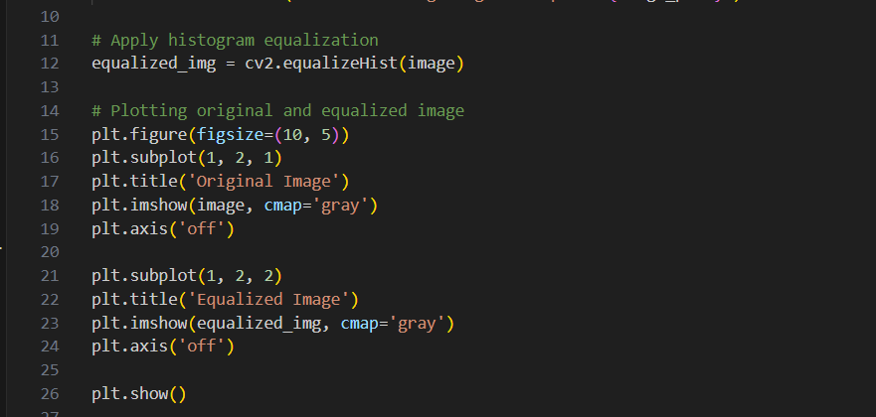

Result:

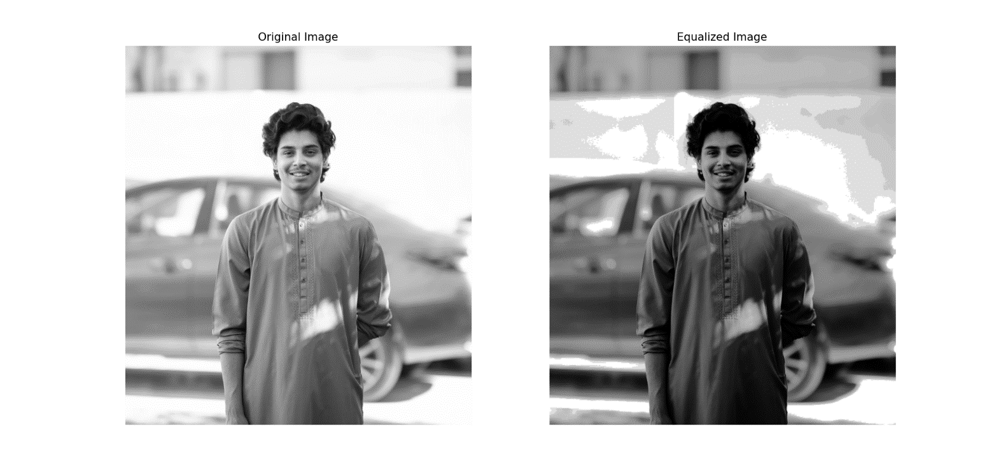

Histogram Matching:

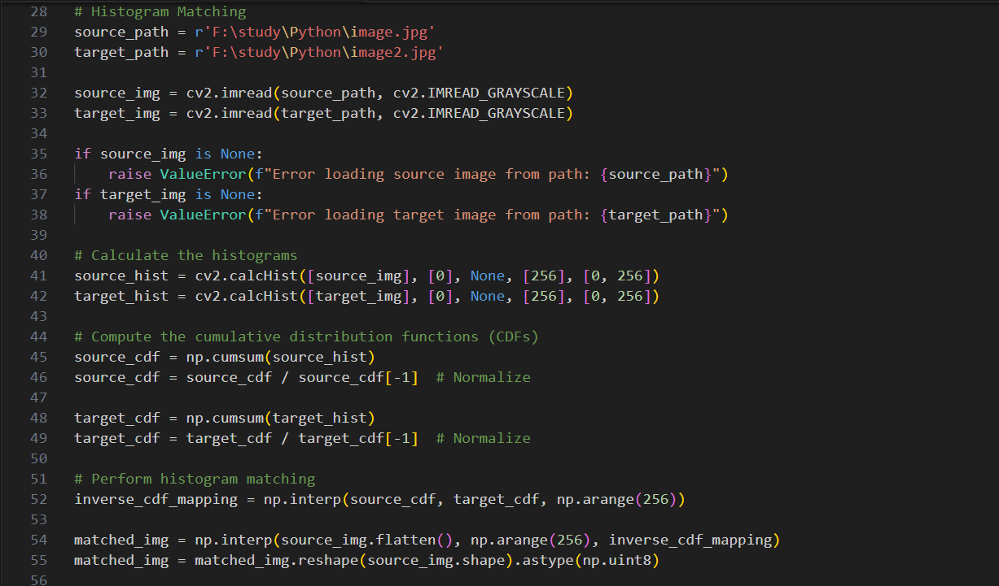

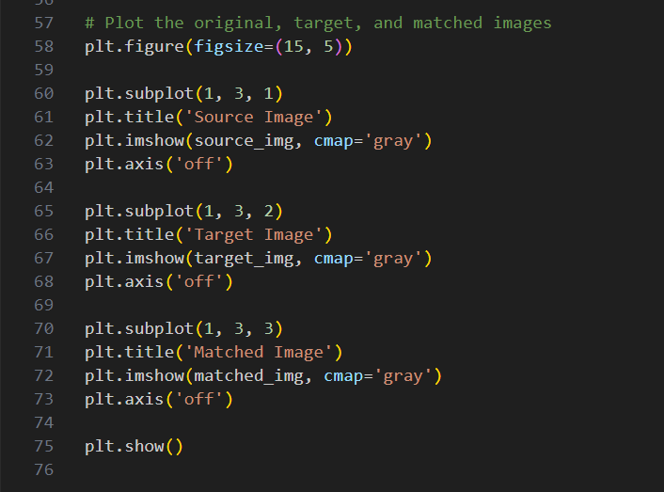

Result:

